# Achieving Financial Freedom

* Demonstrate the approach using a fictional narrative
* Provide links so you can input your own goals and investment assumptions into the calculator by following [these instructions](https://poppertech.com/instructions)

**The Investor:** Robert is a 22 year old management consultant who wants to achieve financial freedom. Specifically, he believes that if he accumulates $3 million in assets, money would no longer be the primary factor in any major life decision. He wonders: if he invests all of his disposable income, how long would it take him to reach this target?

Robert’s employer pays for an investment adviser, Jim, to guide employees in their 401k allocations. Jim explains that as a general rule, higher risk investments perform better in the long run. Also, investors who are closer to retirement or have families may have less of an appetite for risk. This makes sense to Robert and suggests that he has a competitive advantage over some of the older employees. He has a time horizon that is measure in decades and no immediate cash needs. Therefore, he is in the position to take the maximal amount of risk and reap the rewards in the long term.

Robert asks, “Which of the 401k options has the highest risk-reward profile?” Jim explains, “The Emerging Markets Equity Index has historically had both the best and most volatile performance.” His decision made, Robert wants to know how long he should expect to wait before he reaches his target.

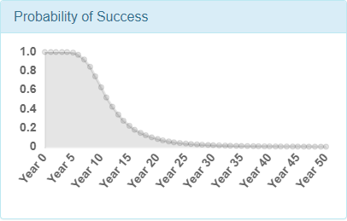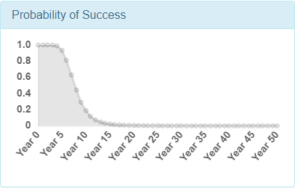**The Financial Planner:** Carla simulates the performance of $200,000 invested in each stock and annuities using the Probicast software. Each simulated year, a $40,000 withdrawal is subtracted from the invested amount. If the portfolio value is insufficient to cover the withdrawal, then the lifetime simulation is a failure. Otherwise, it is counted as a success. Carla generates 1000 lifetime simulations and only 19% successfully cover the required cash flows. Mabel wonders if a different allocation would yield a better result. Carla repeats the calculations for various portfolios as indicated in Graph 1.

***Graph 1: Probability of Goal Attainment for $200,000 and $400,000 invested in Stocks based on a budget of $400,000, initial cash outflow of $40,000, and 2% inflation. Annuity assumed to pay 6% of principal. Note: investing in annuity alone would never meet required outflows and is not shown.***

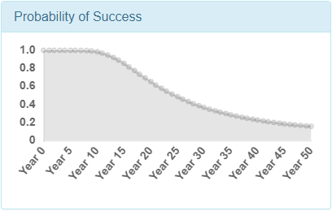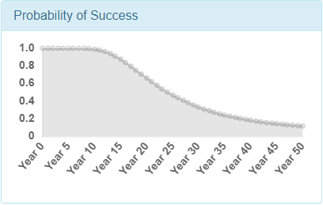Investing in 100% stocks seems to be the best choice since it results in the highest probability of success for 10 years. However, she only would have a 2.6 % chance of success of meeting the cash flows over 30 years. This seems low to Mabel. She wonders: what would happen if they adjusted the cash flows to be $20,000 instead? Graph 2 summarizes these results.

***Graph 2: Probability of Goal Attainment for $200,000 and $400,000 invested in Stocks based on a budget of $400,000, initial cash outflow of $20,000, and 2% inflation. Annuity assumed to pay 6% of principal. Note: investing in annuity alone would give a 100% probability of meeting cash flow until year 19 when it falls to zero.***

This scenario presents a dilemma. Additional amounts invested in the annuity increase the probability of meeting cash flows after ten years but come at the cost of increasing the chance of not meeting cash flows at year 30. If Mabel is more concerned about meeting cash flows over the next 10 years, she might consider allocating a significant portion of her funds to the annuity.

**The Investment Analyst:** To create the above analysis, Carla relied on forecasts from Chris, an investment analyst. In particular, she needed a long-term forecast for stocks. Chris started with historical data for the S&P 500 (SPY) as a baseline and then altered the estimates based on his judgment to create a realistic prediction. First, he collected daily stock market gains and losses from 12/1/2007 to 12/1/2017. He resampled these with replacement 1000 times for 252 simulated trading days to approximate annual performance. Table 1 summarizes the results:

|  |  |  |  |  |
| --- | --- | --- | --- | --- |
| Minimum | 10th Percentile | Median | 90th Percentile | Maximum |
| -48.7% | -16.3% | 8.9% | 40.0% | 120.3% |

***Table 1: Annual summary statistics from resampled gains and losses of the SPDR S&P 500 ETF from 12/1/2007 through 12/1/2017 (Daily Gains and Losses from Yahoo Finance)***

To alter this baseline forecast to fit his beliefs, he performed the following steps:

1. *Assumed the most likely scenario is equal to the median.*
2. *Adjusted the historical minimum and maximum to be symmetrical:* He changed the Minimum scenario to be -50% and the Maximum to 50%.
3. *Estimated the average investment gain:* Chris spent a great deal of effort on this assumption. He reasoned that the stock market should outperform treasury bonds over the long term. Therefore, the current yield of 3% on 10 Treasuries might constitute a lower bound for the long-term expected gain of stocks. At the other extreme, US stocks have historically performed extraordinarily well. The historical analysis indicates the average gain on stocks over the past 10 years is approximately 10% a year. Chris believes this is overly optimistic for the future. He consulted the following [Vanguard paper for other methods](https://personal.vanguard.com/pdf/s338.pdf). The CAPE ratio of 33 indicates a 3% long-term gain. Forward price-to-earnings of 18 suggests 5.6%. At last, he estimated a 5% long-term expected gain, which is roughly the 10 year treasury yield plus the target inflation of the Federal Reserve.
4. *Estimated Volatility:* Chris referenced the VIX, which is at 22. The historical data indicates a volatility ([Standard Deviation](https://en.wikipedia.org/wiki/Standard_deviation)) of 25. Since the historical period contained an abnormally volatile period and the current volatility is above historical norms, Chris estimated a volatility of 16.
5. *Estimated Gain vs Loss Asymmetry:* Although the historical period resulted in a positively asymmetrical profile (.54 [Skewness](https://en.wikipedia.org/wiki/Skewness)), it is late in the business cycle; consequently, Chris projects a slightly negative asymmetry of future gains and losses relative to the average gain (-.28).
6. *Estimated Frequency of Extreme Gains and Losses:* The historical data exhibit more frequent extreme gains and losses than the normal distribution ([Excess Kurtosis](https://en.wikipedia.org/wiki/Kurtosis#Excess_kurtosis) of .9). Chris references [a paper indicating that financial data is more chaotic than Modern Portfolio Theory acknowledges.](https://www.jstor.org/stable/2350970) With this in mind, he estimated more frequent extreme events (Excess Kurtosis of .54) than the “bell-curve” would suggest.

**The Investment Software:** After performing these steps, Chris enters his estimates into the Probicast software. The software draws the probability distribution shown in Graph 3:

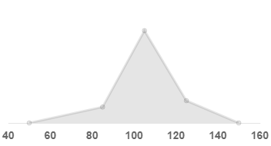

***Graph 3: Estimated annual long-term forecast for the stock market assuming a current price of 100. The software generates the above graphs based on the input scenarios and interpolating straight lines between each scenario.***

Each scenario is connected to the next with a straight line. Probicast generates 1 million random numbers meant to simulate probabilities and maps them to simulated prices based on the above graph. For example, simulated probabilities of 0, .5, and 1 would map to 50, 105, and 150, respectively. It then transforms the simulated investment performance into the results Carla presents to Mabel.

**Input Your Own Assumptions:** The above narrative provides the default inputs for this [investment calculator](https://poppertech.com/choosing-investments-based-on-retirement-goals). You can upload your own cash flow and investment assumptions by following [these instructions](https://poppertech.com/instructions). The calculator is free to use and requires no personal information. Please feel free to share your modifications in the comments section below as well as any questions you may have.